Report upload

(v 1.0)

Guide

(V 1.0)

Contents

1. Introduction 3

2. Pre-requisites 3

3. Initial Settings 3

3.1. Report upload project settings 3

3.2. Security Settings 3

4. Procedure 4

4.1. Uploading using report upload project 4

4.2. reports uploading manually 4

5. Advanced Settings 7

6. Revision Sheet 7

# Introduction

Report Upload Project is to automate the process of uploading Reports to reports server and setting their shared data sources.

This manual will help the user on how to use Report Upload Project in detail. Report Upload Project Settings

# Pre-requisites

1. SQL webserver 2008 and above with management studio
2. SRSS - SQL reporting server services
3. All the Reports required to upload
4. Win 7 and above operating system in the laptop/desktop

# Initial Settings

## Report upload project settings

* + 1. Copy all the Reports(.rdl files) in ‘ReportsToDeploy’ folder under ‘REPORT UPLOAD’ folder
    2. Copy ‘ReportDataSource.rds’ file from the ‘REPORT UPLOAD’ to ‘ReportsToDeploy’ folder (if does not exist already).

## Security Settings

1. From the Dropdown menu of a folder or file, select manage.

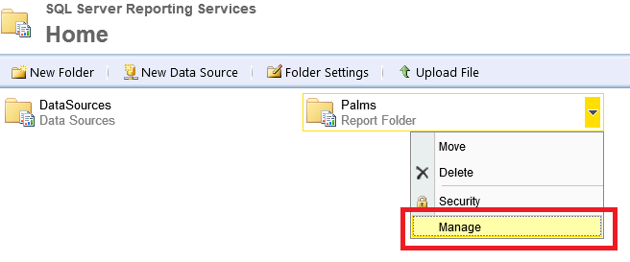

1. Then select security🡪 ‘Edit Item Security’🡪 new Role assignment

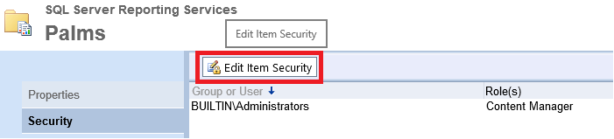

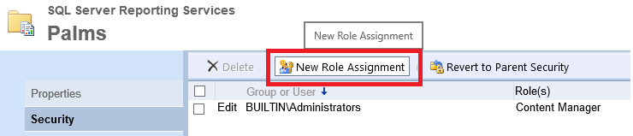

1. Type ‘Everyone’ in username textbox, select all role and click ok.

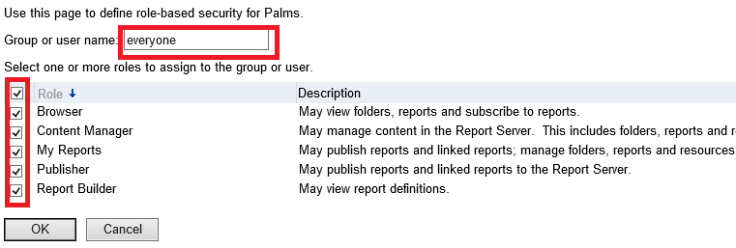

# Procedure

## Uploading using report upload project

1. Open the ‘Deploy_rdl.cmd’ in Notepad
2. Update the REPORTSERVERIP variable and REPORTSERVER variable according to the report server URL.

(Default: - REPORTSERVERIP=localhost; REPORTSERVER=<http://localhost/reports>erver)

1. Run the ‘Deploy_rdl.cmd’ batch file as Administrator and wait for execution.
2. Once the execution is complete, the command window will close. Check ‘RS Scripter log.txt’ file for any errors
3. RS Scripter log have 3 sections.
   1. First for Creating Folder at the report server
   2. Second for reading and uploading Reports and Data source file from the ‘ReportsToDeploy’ folder to the report server
   3. Third for setting shared data source of each report present in the reports folder on server
4. If any error occur for any report, you can always upload that report and set data source manually as explained in 4.2.
5. Once the reports and data source are uploaded, change the connection string and Credentials for data source.
   1. Open report server URL (Default:- <http://localhost/reports>)
   2. Open data source folder and from dropdown menu of 'Report’ data source, select manage.
   3. Now Update connection string and Credentials for connection as explained in reports uploading manually 4.2.1.e. and 4.2.1.f.
6. For any advanced setting, refer 5. Advanced Settings

## reports uploading manually

* + 1. Data Source Setup

1. Open your report server URL. (Default:- <http://localhost/reports>)

(User can check report server URL in reporting services configuration manager)

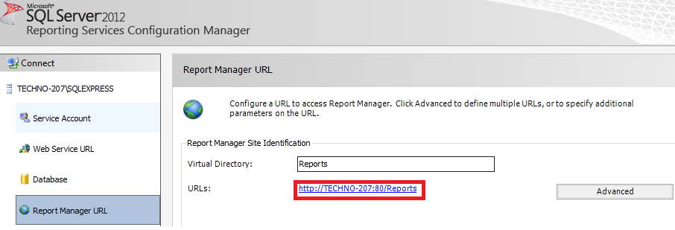

1. Create new folder ‘DataSource’ using ‘New folder’ menu option on server home location.
2. Open DataSource folder click ‘New Data Source’.

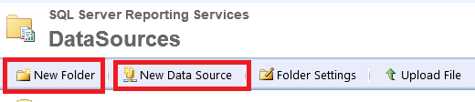

1. Set name of DataSource as ‘ReportDataSource’
2. Add connection string to the Connection string textbox.

(Example: - Server=ServerName; Database=DBName; uid=Username; pwd=password).

1. For ‘Connection using’ option, select ‘Credentials stored securely in the report server’ radio button, and give credentials.

(User Name: - Username and password: - Password)

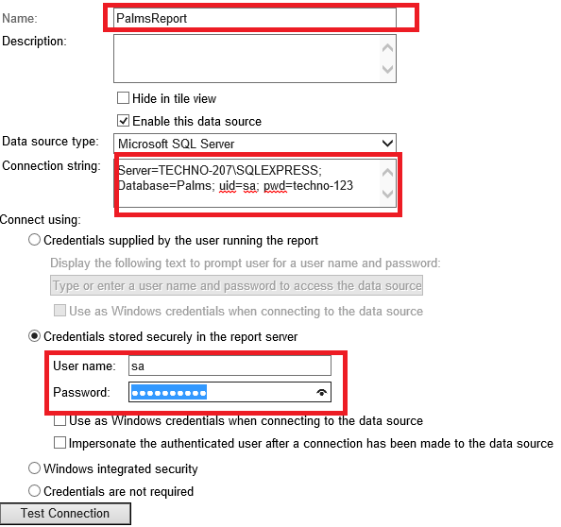

1. Click ok
   * 1. Report setup
2. Now create new folder Reports (if doesn’t exist) on server home location
3. Open folder and click ‘Upload File’ option

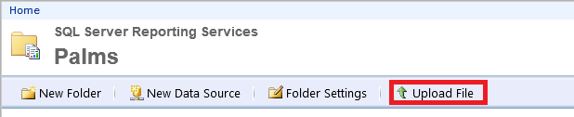

1. Browse Report and click upload
2. From Dropdown menu of uploaded report, select ‘Manage’
3. Select ‘Data Sources’ option 🡪 ‘a shared data source’ radio button and browse the data source you created. Then click Apply at the bottom.

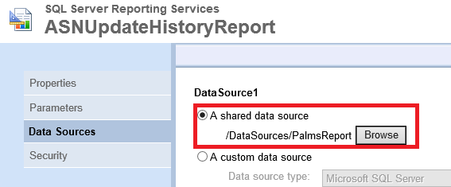

1. Test Reports by opening them on server and in application.

# Advanced Settings

User can change Variables names in ‘Deploy_rdl.cmd’ batch files as required.

1. Open ‘Deploy_rdl.cmd’ in notepad
2. Name of variables with use
3. LOGFILE = name of txt file which gets generated after batch file execution with log
4. SCRIPTFULLPATH = path of ‘DeployReports.rss’ file path which has code for different utilities i.e. for folder creation, file upload and shared data source update.
5. REPORTFOLDER = name of report folder to create on server
6. DATASOURCEFOLDER = name of data sources folder to create on server
7. DATASOURCEPATH = path of data source folder on server (do not change)
8. REPORTSERVERIP = report server IP
9. REPORTSERVER = report server URL
10. RS = RS.EXE utilities name (do not change)
11. FilesToUploadPath = Folder path which contains Reports (.rdl files) and data source (.rds file) that to be uploaded
12. DATASOURCENAME = Data source name(.rds file) which has to be set as shared data source for all .RDL files at REPORTFOLDER on server
13. TIMEOUT = time out

# Revision Sheet

|  |  |  |
| --- | --- | --- |
| **Revision** | **Date** | **Description** |
| Version 1.0 | Feb 15, 2018 | Created by Anshul Vanawat |
|  |  |  |
|  |  |  |
|  |  |  |